# **Rational**

**Reasons**

A website for Elevate Norfolk is needed to allow customers to view, book and query about available lifts for construction or maintenance. The original reason for Elevate Norfolk was because the cost of hiring and buying equipment such as scissor lifts would be costing businesses lots of money so Elevate Norfolk will buy the equipment and allow customers to hire it out for a day or a week or for how long they need it. The sister company partnership with Norfolk doors which is a construction company and that they are both fairly small but local companies which is better for other smaller businesses and also individuals who only need a piece of equipment for say having a door fitted or small bits of construction as they will only hire a lift for a small amount of time. However, say if it's quite a big building site their might have to be a driver with them on with them if a builder is not eligible to be on one on their own as they haven't completed the certain course yet. But the main reason for Elevate Norfolk being set up is to keep Norfolk Doors’ costs down by not having to hire any equipment and to also help other companies and other individuals who need assistance of a piece of construction equipment.

**Opportunities / Problems**

|  |  |
| --- | --- |
| **Opportunity** | **Problems that could arise** |
| Adding a search feature so users can find certain type of lifts that will suit them or their situation [e.g. Scissor lifts] | Could become inaccurate with limited user input [e.g. if someone want scissor lifts but they only type ‘s’] |
| Adding a Section to contact support to allow any questions or queries related to maintenance, satisfaction or damages to the machinery causing it to not work. | Could fill up the network with spam, phishing or cold calls which could block out legitimate queries  Potential for DoS attacks through mass botting of requests  Not all people can talk on the phone very well which could become a problem if calls are the only option for communication  Not everyone may have unlimited calls on mobile, meaning the time in which they can speak could be very limited |

**Target Audience and Stakeholders**

|  |  |  |
| --- | --- | --- |
| **Stakeholder** | **Positive effects** | **Negative effects** |
| Individuals or Contractors | + Can mitigate most risks presented with using conventional ladders  + A Simple and easy website interface will get customers to where they need to look without much issue, causing them to avoid looking at other, less local companies.  + Times of hire can be flexible, meaning if someone needs it for only a single day, compared to a week, they can hire it for that single day, or 4, without having to pay for only a few set plans. | - Not everyone can understand how the machinery will work, which may cause injuries and problems for the renter.  - joint failure is present in both ladders and some heavy machinery, which may uphold more risk than it solves.  - Not all customers have internet access and may not be able to call or book any machinery through the website, especially if unknown to the customer  - Customers may get bored of a website that either has not enough visuals, or is too hard to navigate |
| Small / Medium Businesses | + Better for longer or more complex projects hosted by the target company as they will need to use the equipment more often over the period of the construction, then individuals, would.  + Good for companies in Norfolk and east Anglia as they are local to the area, compared to other businesses around the UK therefore the transportation of the required equipment is less likely to get damaged due to the lower distance to travel from the supplier to the client.  + Partnerships can be made between the company and the renter which could lead to some royalties on demand | - Some businesses might not have a driver to operate the machinery, which could cause risks with transporting or operating the machinery, possibly placing workers into unnecessary risk.  - If small or medium companies choose a different service over Elevating Norfolk, profits could diminish, especially if most of the partnerships have gone for better brands. |

**Objectives and Goals**

Goal to reduce reliance on external suppliers & provide direct service to businesses and individuals in need of platform rental.

Objective is to develop a strong brand identity, an engaging online presence, and an easy-to-use booking system to facilitate customer interaction and orders. : u

**Feasible? (is it able to be done)**

When considering other companies like Uphire in the UK, we can see a version of hiring scissor lifts as seen highlighted below:

When opening the page, it supplies you with specifications and an operating guide attached with the scissor Skyjack as this example, shown below:

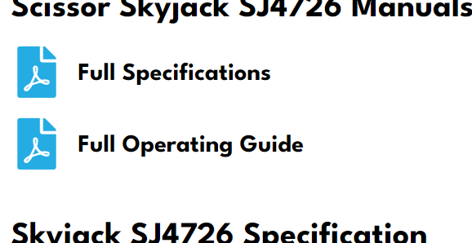

We can also see on the page a step-by-step guide on hiring from the company which could help with prices, an example of some data you could add is below:

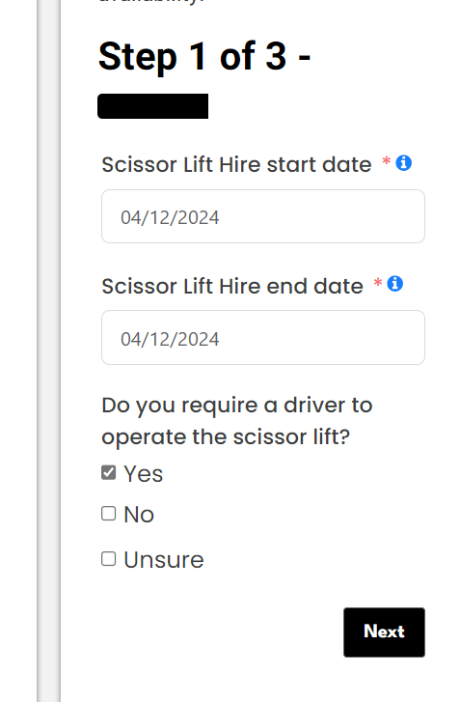

A problem found with the website is that the tick boxes for when it asks if a driver is required, the user can tick all 3 boxes which shouldn’t be necessary as it's a yes, no question you can’t say both and there is an unsure button in case. Also, this should really be a required answer as it is important information for the company to know. This can be shown below:

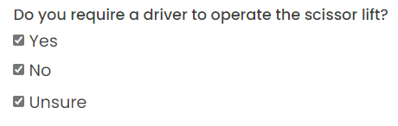

It is not a good idea to have all boxes be able to be checked as it could confuse the company [Uphire] about if the client wants or needs a sufficient driver or not.

After pressing next, it takes you to a section where it asks for some information to contact the person hiring, although the company name being asked for may be confusing, it could be used to find the location of the company HQ to send the lift if an insufficient post code or town / city has been provided. This has been shown with example inputs below:

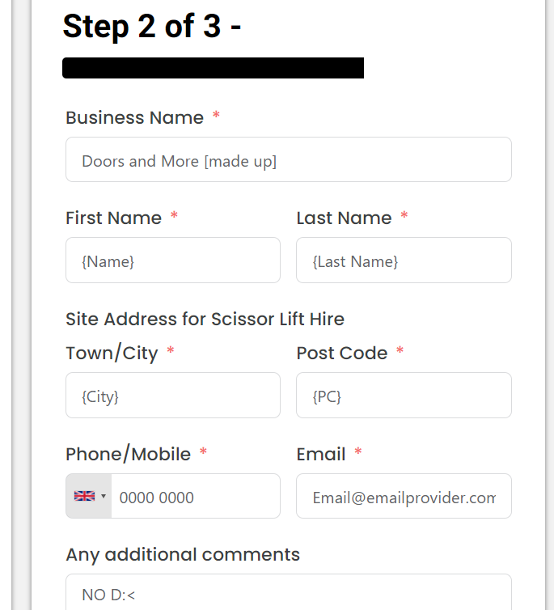

DISCLAIMER: We do not own the right to ‘Doors and More’ as it is an actual company name which we knew nothing about until we researched it, nor that we are implying that ‘Doors and More’ is a made-up company! We did not intend on making them seem worthless or just an imaginary company or use their name as a joke.

Finally, after submitting the required data, you would agree to the terms and conditions [indicated by just a checkmark so people can just not read it] and submit a form for hiring the scissor lift. The final page looks something like:

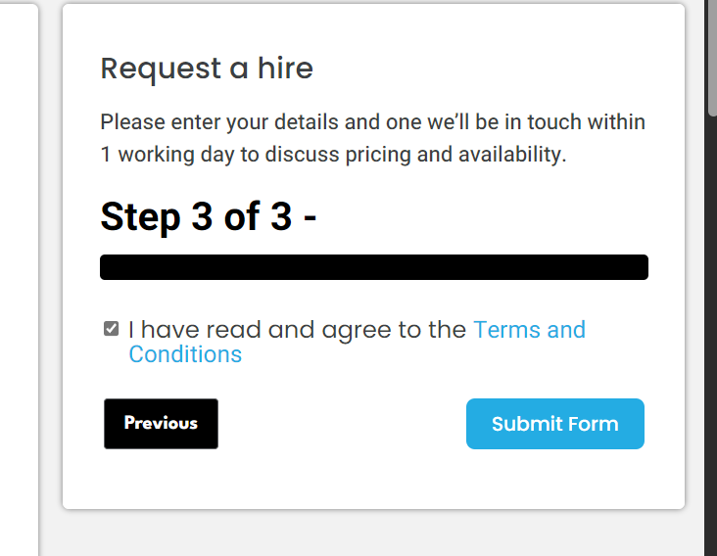

In Conclusion, this project is very feasible due to the example of how a hiring system online would work & the little errors we have found on other websites, so we know not to include it and to make Elevate Norfolk’s website better than the rest. Inspiring us to not only fixing the errors made by the company, but to also inspire our design for the prototype of the website.